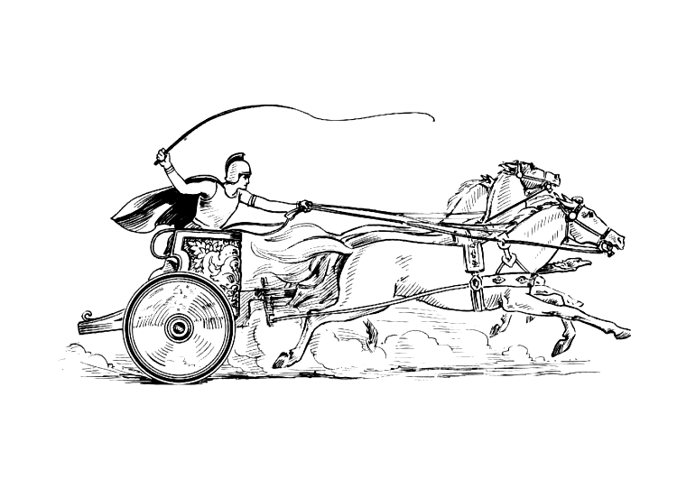
Mancetter Parish Council
Parish Clerk: Elane Higgins
Parish Registered Address:
Mancetter Memorial Hall, Old Farm Road, Mancetter.
CV9 1QN
Telephone 01827 722552/07368 265051
Email: parishclerk@mancetterparishcouncil.gov.uk
www.mancetterparishcouncil.gov.uk

MEETING DATES 2024 / 2025

Meetings are held bi-monthly usually on the fourth Tuesday of the month at St Peter’s Church Mancetter, starting at 7pm.

Members of the public are welcome to attend.

23rd April 2024
Official Annual Parish Meeting for Residents
and Local Community Groups
28th May 2024
Annual Parish Council Meeting for New Council Year.
23rd July 2024
18th September 2024
Informal Parish Meeting for Residents and Local Community Groups (at Ridge Lane Chapel and Community Room)
24th September 2024
26th November 2024
28th January 2025
25th March 2025

